Repo link:
https://github.uconn.edu/CSE2102-Spring25/Dominic-Rossi-22011

Resources:
https://huskyct.uconn.edu/ultra/courses/_173302_1/outline
https://chatgpt.com (Find certain commands)

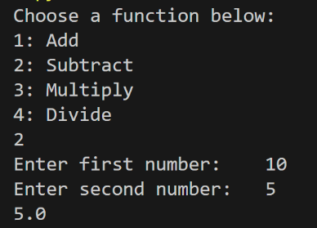
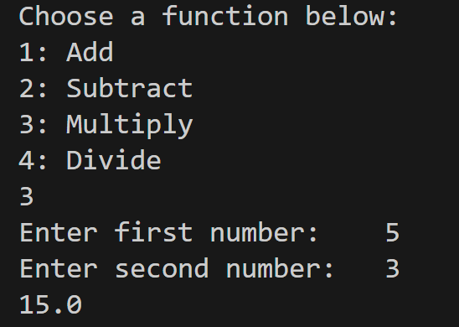
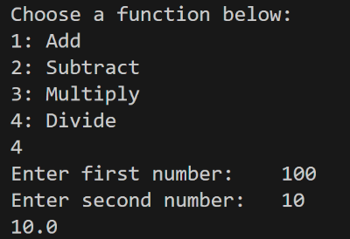
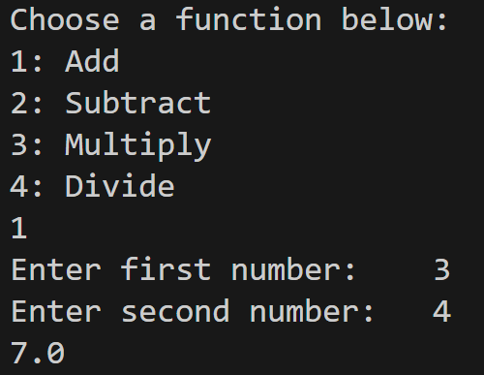
Basic Runs:

Addition Subtraction Multiplication Division

Command Line Outputs:

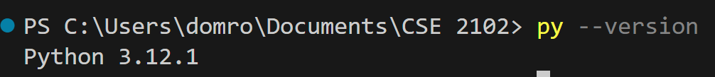

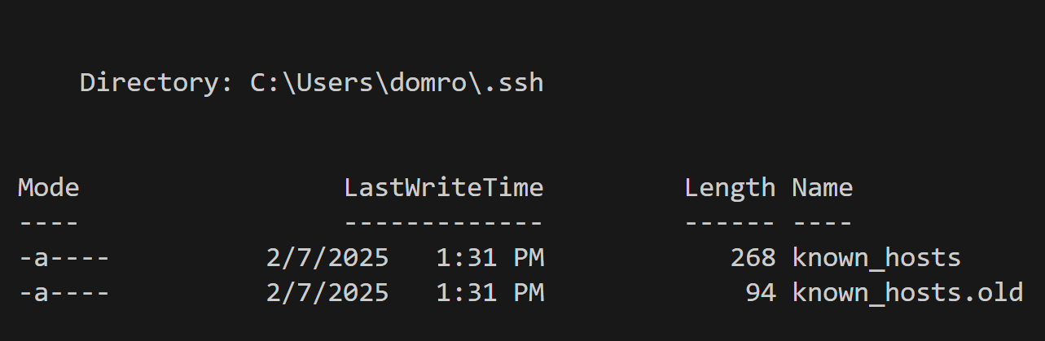

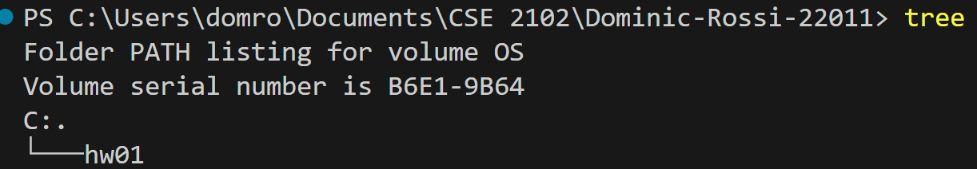

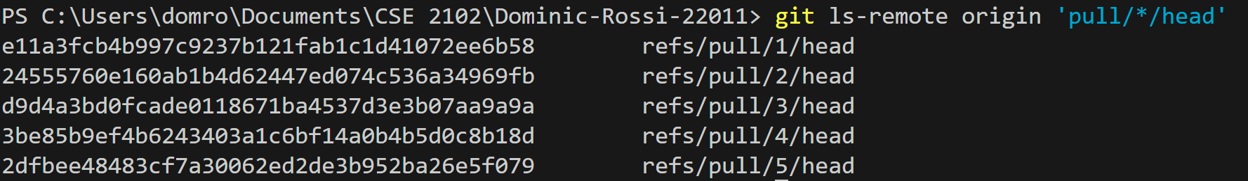
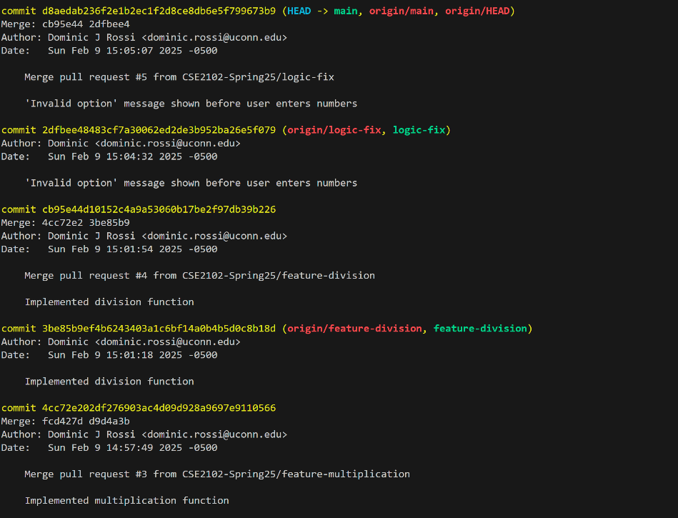
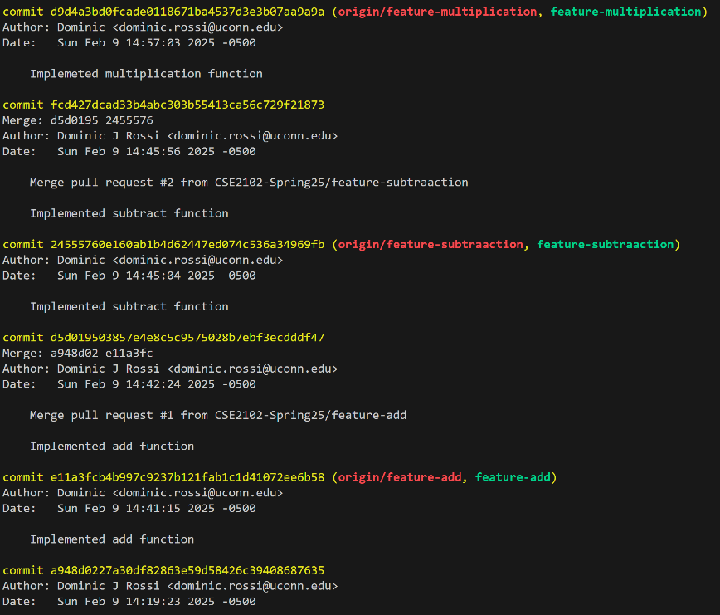
c

